East China University Of Science
（211 http://ies.ecust.edu.cn ）
East China university of science and technology is located in China's economic, financial, trade, shipping center —— Shanghai, founded in 1952, formerly known as east China institute of chemical industry, is a national key university directly under the Ministry of Education, is the first so chemical characteristics, national "211 project" and "985 advantage discipline innovation platform" key construction, is one of the national "double top" construction of colleges and universities, is a characteristic, multidisciplinary coordinated development of research national key university. In the international ranking of the Basic Science Index database (ESI), East China University of Science and Technology has five disciplines in the top one percent of the world, namely chemistry, Materials Science, Engineering, Biology and biochemistry, Pharmacology and Toxicology. In 2014, the major of Chemical Engineering and Technology passed the American ABET Engineering Education Professional certification, which is the first major to pass the certification in China.
The university has three parts: Xuhui Campus, Fengxian Campus and Jinshan Science and Technology Park, with 20 colleges, covering 64 undergraduate programs covering 11 disciplines of science, engineering, agriculture, medicine, economics, management, literature, law, art, philosophy and education. Among them, there are 1 English undergraduate program, 16 English master's programs and 20 English doctoral programs. There are 12 post-doctoral research stations, 7 national key disciplines, 1 national key (cultivation) discipline, 10 key disciplines in Shanghai, 7 first-class disciplines in Shanghai universities, and 3 "double first-class" construction disciplines. The university has more than 3,000 staff and nearly 26,000 students, including nearly 1,400 international students from 100 countries.
East China University of Science and Technology is a university authorized by the Ministry of Education of China to recruit international students. Since 1956, it began to receive and train international students, and has trained tens of thousands of international students from more than 140 countries. Founded in 2006, it is located in the main campus of the university, ——. It is the window of East China University of Science and Technology for international students. It is responsible for international students enrollment, teaching coordination, daily management and life services. International students apply for bachelor's, master's and doctor's degrees and professional study in East China University of Science and Technology through the School of International Education. At the same time, the college has a Chinese language teaching center, which can conduct long-term and short-term Chinese language training, and hold various short-term classes and customized training courses for Chinese language culture. The School of International Education adheres to the concept of people-oriented and serving students, and is committed to creating a good learning and living environment for international students.

Professional information
undergraduate course
name of major | Length of schooling (year) | Teaching language | Tuition fee (RMB / academic year)
Digital media art | 4 | Chinese | 26000
Visual communication design | 4 | Chinese | 26000
environmental design | 4 | Chinese | 26000
products design | 4 | Chinese | 26000
pharmacy | 4 | Chinese | 22000
English | 4 | Chinese | 22000
Japanese | 4 | Chinese | 22000
German | 4 | Chinese | 22000
applied physics | 4 | Chinese | 22000
Information and Computational Science | 4 | Chinese | 22000
In Mathematics and Applied Mathematics | 4 | Chinese | 22000
bio-science | 4 | Chinese | 22000
biotechnology | 4 | Chinese | 22000
applied chemistry | 4 | Chinese | 22000
chemistry | 4 | Chinese | 22000
economics | 4 | Chinese | 22000
science of banking | 4 | Chinese | 22000
physical distribution management | 4 | Chinese | 22000
Information management and information systems | 4 | Chinese | 22000
engineering management | 4 | Chinese | 22000
administration | 4 | Chinese | 22000
Labor and Social Security | 4 | Chinese | 22000
PSA | 4 | Chinese | 22000
marketing management | 4 | Chinese | 22000
HRM | 4 | Chinese | 22000
accounting | 4 | Chinese | 22000
business administration | 4 | Chinese | 22000
financial management | 4 | Chinese | 22000
robotization | 4 | Chinese | 22000
Food quality and safety | 4 | Chinese | 22000
Of Food Science and Engineering | 4 | Chinese | 22000
bioengineering | 4 | Chinese | 22000
Light engineering | 4 | Chinese | 22000
Energy and power engineering | 4 | Chinese | 22000
oil-gas storage and transportation engineering | 4 | Chinese | 22000
landscape architecture | 4 | Chinese | 26000
Intelligent science and technology | 4 | Chinese | 22000
software engineering | 4 | Chinese | 22000
And Computer Science and Technology | 4 | Chinese | 22000
Mechanical design and manufacture and its automation | 4 | Chinese | 22000
Process equipment and control engineering | 4 | Chinese | 22000
industrial design | 4 | Chinese | 22000
environment engineering | 4 | Chinese | 22000
Resource recycling science and Engineering | 4 | Chinese | 22000
pharmaceutical engineering | 4 | Chinese | 22000
Chemical engineering and the process | 4 | Chinese | 22000
information technology | 4 | Chinese | 22000
Optoelectronic Information Science and Engineering | 4 | Chinese | 22000
Electrical engineering and its automation | 4 | Chinese | 22000
New energy materials and devices | 4 | Chinese | 22000
Inorganic, nonmetallic material engineering | 4 | Chinese | 22000
Of Polymer Materials and Engineering | 4 | Chinese | 22000
Composite Materials and Engineering | 4 | Chinese | 22000
materials chemistry | 4 | Chinese | 22000
sociology | 4 | Chinese | 22000
work | 4 | Chinese | 22000
law | 4 | Chinese | 22000

Master research
name of major | Length of schooling (year) | Teaching language | Tuition fee (RMB / academic year)
design science | 2.5 | Chinese | 30000
landscape design | 2.5 | Chinese | 30000
Design art | 2.5 | Chinese | 30000
philosophy | 2.5 | Chinese | 28000
pharmacy | 3 | Chinese | 28000
English language and literature | 2.5 | Chinese | 28000
Japanese language literature | 2.5 | Chinese | 28000
Foreign linguistics and applied linguistics | 2.5 | Chinese | 28000
Biomedical Engineering (in Science) | 3 | Chinese | 28000
Fine synthetic chemistry and molecular engineering | 3 | English | 34000
Fine synthetic chemistry and molecular engineering | 3 | Chinese | 28000
inorganic chemistry | 3 | English | 34000
inorganic chemistry | 3 | Chinese | 28000
analytical chemistry | 3 | English | 34000
analytical chemistry | 3 | Chinese | 28000
organic chemistry | 3 | English | 34000
organic chemistry | 3 | Chinese | 28000
physical chemistry | 3 | English | 34000
physical chemistry | 3 | Chinese | 28000
Polymer chemistry and physics | 3 | Chinese | 28000
chemistry | 3 | English | 34000
chemistry | 3 | Chinese | 28000
biology | 3 | English | 34000
biology | 3 | Chinese | 28000
microbiology | 3 | English | 34000
microbiology | 3 | Chinese | 28000
Biochemistry and Molecular Biology | 3 | English | 34000
Biochemistry and Molecular Biology | 3 | Chinese | 28000
mathematics | 3 | Chinese | 28000
physics | 3 | Chinese | 28000
applied economics | 2.5 | Chinese | 28000
International trade | 2.5 | Chinese | 28000
Higher education | 2.5 | Chinese | 28000
education | 2.5 | Chinese | 28000
The Sociology of Sports Humanities | 2.5 | Chinese | 28000
business administration | 2.5 | English | 34000
business administration | 2.5 | Chinese | 28000
Management Science and Engineering | 2.5 | Chinese | 28000
social policies | 2.5 | Chinese | 28000
administration | 2.5 | Chinese | 28000
social security | 2.5 | Chinese | 28000
bioengineering | 3 | English | 34000
bioengineering | 3 | Chinese | 28000
Safety Science and Engineering | 3 | Chinese | 28000
polymers | 3 | English | 34000
polymers | 3 | Chinese | 28000
Optical information physics and quantum materials | 3 | Chinese | 28000
Advanced materials and preparation techniques | 3 | Chinese | 28000
Materials and Chemical Industry | 3 | English | 34000
Materials and Chemical Industry | 3 | Chinese | 28000
Polymer materials engineering | 3 | English | 34000
Polymer materials engineering | 3 | Chinese | 28000
Nanomaterials and nanotechnology | 3 | English | 34000
Nanomaterials and nanotechnology | 3 | Chinese | 28000
And Materials Science and Engineering | 3 | English | 34000
And Materials Science and Engineering | 3 | Chinese | 28000
Materials Science and Technology | 3 | English | 34000
Materials Science and Technology | 3 | Chinese | 28000
Material chemical industry | 3 | English | 34000
Material chemical industry | 3 | Chinese | 28000
Biomaterials | 3 | English | 34000
Biomaterials | 3 | Chinese | 28000
Material physics and chemistry | 3 | English | 34000
Material physics and chemistry | 3 | Chinese | 28000
material science | 3 | English | 34000
material science | 3 | Chinese | 28000
Material processing engineering | 3 | English | 34000
Material processing engineering | 3 | Chinese | 28000
Power engineering and engineering thermophysics | 3 | English | 34000
Power engineering and engineering thermophysics | 3 | Chinese | 28000
Thermal energy engineering | 3 | English | 34000
Thermal energy engineering | 3 | Chinese | 28000
Energy engineering and technology | 3 | English | 34000
Energy engineering and technology | 3 | Chinese | 28000
Chemical engineering of materials | 3 | English | 34000
Chemical engineering of materials | 3 | Chinese | 28000
process system engineering | 3 | English | 34000
process system engineering | 3 | Chinese | 28000
Of Chemical Engineering and Technology | 3 | English | 34000
Of Chemical Engineering and Technology | 3 | Chinese | 28000
Energy chemical industry | 3 | English | 34000
Energy chemical industry | 3 | Chinese | 28000
industry of fine chemicals | 3 | English | 34000
industry of fine chemicals | 3 | Chinese | 28000
Chemical and pharmaceutical | 3 | English | 34000
Chemical and pharmaceutical | 3 | Chinese | 28000
chemical engineering | 3 | English | 34000
chemical engineering | 3 | Chinese | 28000
chemical technology | 3 | English | 34000
chemical technology | 3 | Chinese | 28000
biochemical engineering | 3 | English | 34000
biochemical engineering | 3 | Chinese | 28000
applied chemistry | 3 | English | 34000
applied chemistry | 3 | Chinese | 28000
Industrial catalysis | 3 | English | 34000
Industrial catalysis | 3 | Chinese | 28000
Environmental Science and Engineering (Engineering) | 3 | English | 34000
Environmental Science and Engineering (Engineering) | 3 | Chinese | 28000
Environmental Engineering (Engineering) | 3 | English | 34000
Environmental Engineering (Engineering) | 3 | Chinese | 28000
Environmental materials engineering | 3 | English | 34000
Environmental materials engineering | 3 | Chinese | 28000
Environmental chemical industry | 3 | English | 34000
Environmental chemical industry | 3 | Chinese | 28000
mechanical engineering | 3 | Chinese | 28000
And Computer Science and Technology | 3 | English | 34000
And Computer Science and Technology | 3 | Chinese | 28000
computer application technology | 3 | English | 34000
computer application technology | 3 | Chinese | 28000
Control Science and Engineering | 3 | Chinese | 28000
Control theory and control engineering | 3 | Chinese | 28000
Biomedical Engineering (Engineering Engineering) | 3 | Chinese | 28000
Oil and gas engineering | 3 | Chinese | 28000
Food Science and Engineering (Engineering) | 3 | English | 34000
Food Science and Engineering (Engineering) | 3 | Chinese | 28000
Food Science (Engineering) | 3 | English | 34000
Food Science (Engineering) | 3 | Chinese | 28000
Information and Communication Engineering | 3 | English | 34000
Information and Communication Engineering | 3 | Chinese | 28000
work | 2.5 | Chinese | 28000
Marxist theory | 2.5 | Chinese | 28000
law | 2.5 | Chinese | 28000
sociology | 2.5 | English | 34000
sociology | 2.5 | Chinese | 28000
Pesticide learning | 3 | Chinese | 28000
plant protection | 3 | Chinese | 28000

East China University of Science and Technology
1. Scholarship content and standards
Since 2016, East China University of Science and Technology has set up the President Scholarship program for Foreign Students, offering 8 scholarships every year to attract outstanding foreign students to study for master's and doctor's degree.
1) Full scholarship: 3 students, referring to the Chinese Government Scholarship, to support outstanding doctoral students;
2) Some scholarships: 5 students, used to support outstanding master students according to the partial scholarship standards of Shanghai Municipal Government.
2. Open professional
All master's and doctor's degrees are acceptable, and priority is given to key disciplines of the university. The length of schooling is subject to the training program of each major.
3. Applicant qualification
1) Non-Chinese citizens, to be in good health;
2) Applicants for a doctoral degree must have obtained a master's degree and be generally under 40; applicants for a postgraduate degree must have obtained a bachelor's degree and should generally be under 35;
3) Not receiving other scholarship grants simultaneously.
4. Date of application
April 1 every year on May 15.
5. Application materials
Log on to the online international student registration system of East China University of Science and Technology http: / / application.ecust.edu. After registration, select the "East China University of Science and Technology President's Scholarship" project to fill in the online application and upload the following application materials:
1) Application Form for Foreign Students of East China University of Science and Technology (automatically generated after filling in the information online);
2) Copy of the passport
3) Maximum diploma and degree certificate
(Text other than Chinese and English must be accompanied by notarized translations of Chinese or English versions, and fresh graduates must submit the pre-graduation certificate issued by their school.)
4) Study transcripts. Text other than Chinese and English shall be accompanied by notarized translations of Chinese or English
5) Study or research plan in China.(No less than 500 words, written in English)
6) Two letters of recommendation. Applicants must submit letters of recommendation from two professors or associate professors;
7) HSK Certificate (Chinese major)
Mail the above "application form" and "application materials" to the School of International Education, East China University of Science and Technology at the "Contact Information".
7. Contact information
Admissions Office of the School of International Education, East China University of Science and Technology
Address: Room 104, Chenyuan, No.130, Meilong Road, Xuhui District, Shanghai
Postcode: 200237
Tel.: 0086-21-64252371
Fax: 0086-21-64252280
E-mail: cie@ecust.edu.cn
Website: http://ies.ecust.edu.cn
Accommodation environment
room type | hotel expense  (Yuan / year) | Independent toilet | Independent bathroom | broadband | landline telephone | air-conditioning | other
single-room occupancy | 21600 | yes | yes | yes | yes | yes

campus scenery
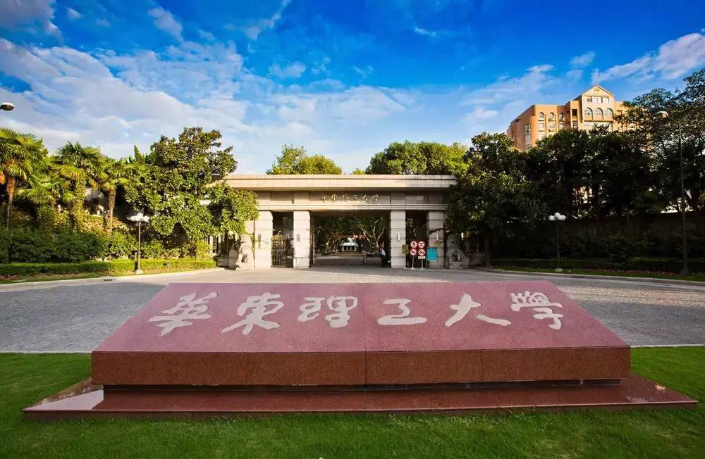
1/16

